**From:** [REDACTED]  
**Sent:** Friday, January 21, 2022 5:11 PM  
**To:** [REDACTED]

**Subject:** RE: PRDemo52 is having critical errors for analytics

All Dashboards have been uploaded with the new Font. I’ve checked a QA instance and can confirm that the changes have gone through.

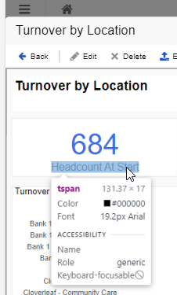

Big thanks to **Eddie** for running QA on this rebuild!

To reiterate on my last email – this only resolves the Font issue for the existing System Dashboards. We need a method to apply a theme across all Power BI dashboards to ensure that they default to Arial as opposed to Segoe UI so that this issue does not pop up in the future. To [REDACTED], this would likely need Dev input so I’ll pass this piece back over to you and the team.

Hope you all have a wonderful weekend!

**From:** [REDACTED]  
**Sent:** Thursday, January 20, 2022 9:34 AM  
**To:** [REDACTED]

**Subject:** RE: PRDemo52 is having critical errors for analytics

I’ve gone through about half of the Dashboards so far and plan to finish off the list today. **Eddie** has offered to step in and QA the edits I’m making – the goal will be to upload the Dashboards for tomorrow.

[REDACTED] these edits will only fix the System Dashboards. The default for Power BI in Ad Hoc will still be Segoe UI, someone will need to go in and update the theme that we apply to all new Dashboards so that they can have a consistent font. I’m not sure how this was setup so it would likely need a small Dev effort.

Thanks,

[REDACTED]

**From**[REDACTED]

**Sent:** Wednesday, January 19, 2022 9:50 AM  
**To:** [REDACTED]

**Subject:** Re: PRDemo52 is having critical errors for analytics

Steve,

I think that we can move forward. Please loop in Eddie so he can help.

Scott

**From:** [REDACTED]

**Date:** Tuesday, January 18, 2022 at 4:11 PM  
**To:** [REDACTED]

**Subject:** RE: PRDemo52 is having critical errors for analytics

Great work, **Eddie**.

@[REDACTED] – do you agree with or have any input into **Eddie’s** proposal?

@[REDACTED] – there are three different areas for which we would need to make the changes.  [REDACTED] can make the changes to the dashboards, but the other areas are all product changes.  Just give us the go ahead and we’ll do our part.

|  |
| --- |
|  |
|  |

**From:** Zare, Eddie

**Sent:** Tuesday, January 18, 2022 4:12 PM  
**To:** [REDACTED]

**Subject:** RE: PRDemo52 is having critical errors for analytics

In regards to the font issue, so far, 3 fonts have been discovered (underlined in red) throughout the interfaces. Screenshots below.

**Segoe UI:**

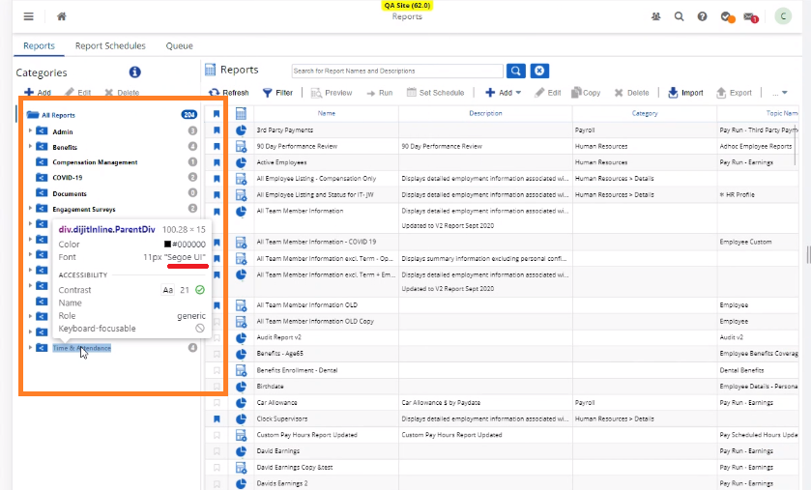

**Open Sans:**

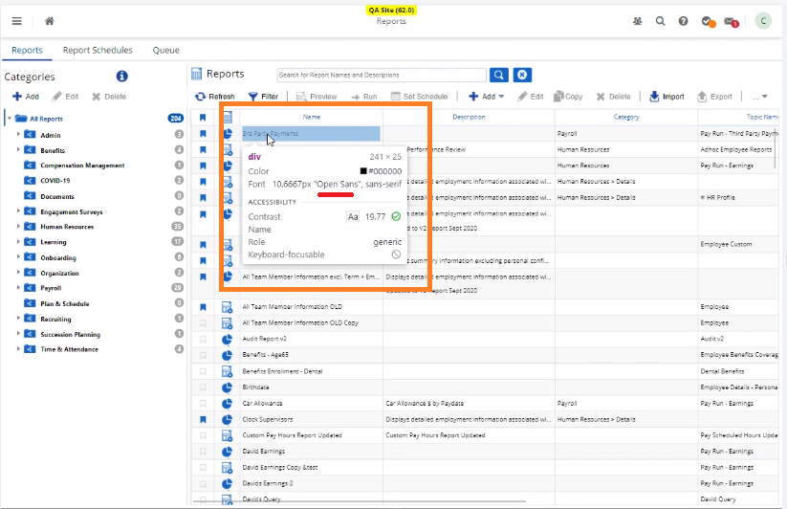

**Arial:**

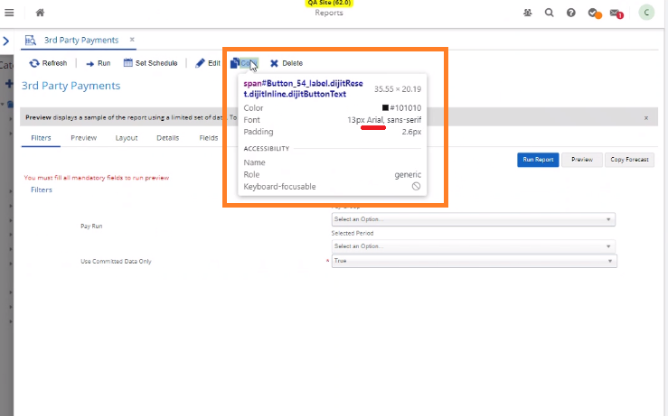

The wiki page Dayforce Design System recommends the Arial font to be used. Reference wiki link [REDACTED]

Per [REDACTED], Arial font is the sole font used for everything.

Additional research showed that Arial (among others) is one of the “universal” fonts (supported everywhere) that can avoid the idiosyncrasies of other operating systems. This includes MacOS, Google OS, Linux/Unix, browsers, etc., when dealing with font allocations. Since there is a large precedent for the Arial font, It is highly recommended to convert these other fonts to **Arial**.